**Objective 7**

**Q write a program of addition of two complex using operator overloading ?**

**Code :**

class A:

def __init__(self,real,image):

self.real=real

self.image=image

#operator overloading pre built operator function to add

def __add__(self,other):

return A(self.real+other.real,self.image+other.image)

def display(self):

print("sum ->",self.real,"+",self.image,"i")

real=int(input("enter the real part of first number:"))

image=int(input("enter the image part of first number :"))

ob1=A(real,image)

real1=int(input("enter the real part of second number:"))

image1=int(input("enter the image part of second number r:"))

ob2=A(real1,image1)

# calling add function

ob3=ob1+ob2

ob3.display()

**output:**

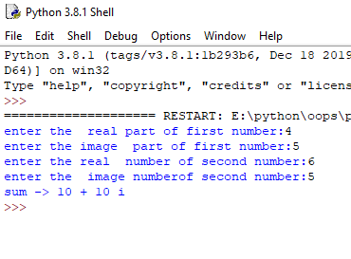

**Q write a program of multiplication of two complex using operator overloading ?**

**Code :**

# multiplication of two complex number

class complex:

def __init__(self,real,image):

self.real=real

self.image=image

def __mul__(self,other):

return complex(((self.real*other.real)-(self.image*other.image)),((self.real*other.image) + (self.image*other.real)))

def display(self):

print(“output”,self.real,"+ ",self.image,"i")

c1=complex(4,5)

c2=complex(2,7)

c3=c1*c2

c3.display()

**output :**

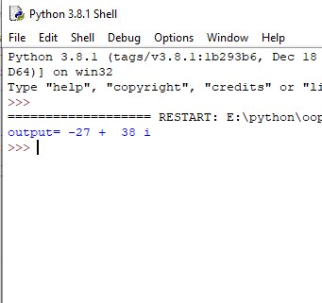

**Q write a program of compare of two complex using operator overloading ?**

**Code :**

# comapring to commplex number

class complex:

def __init__(self,real,image):

self.real=real

self.image=image

def __eq__(self,other):

if self.real==other.real and self.image==other.image :

return True

else:

return False

ob1=complex(1,2)

#ob2=complex(2,1)

ob2=complex(1,2)

ob3 = (ob1==ob2)

print(ob3)

**output:**

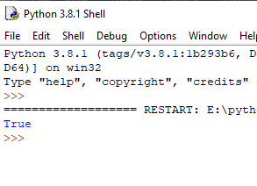

**Q write a programto check which no is greater then out of two complex using operator overloading ?**

**Code :**

# compring to which number is greater

class complex:

def __init__(self,real,image):

self.real=real

self.image=image

def __gt__(self,other):

if self.real>=other.real and self.image >=other.image :

return "number 1 is greater"

else:

return "number 2 is greater"

ob1=complex(1,2)

#ob2=complex(2,1)

ob2=complex(4,6)

ob3 = ob1>ob2

print(ob3)

**output:**

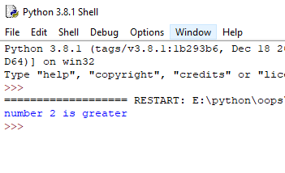

**Q write a program to check which no is lesser then out of two complex using operator overloading ?**

**Code :**

# compring to which number is less

class complex:

def __init__(self,real,image):

self.real=real

self.image=image

def __lt__(self,other):

if self.real>=other.real and self.image >=other.image :

print(other.real," + ",other.image,"i","is less")

else:

print(self.real," + ",self.image,"i","is less")

ob1=complex(1,2)

#ob2=complex(2,1)

ob2=complex(4,6)

ob3 = ob1<ob2

**output:**

